1. [**How to Configure Ip address to PC and Routers in Packet Tracer**](http://chennaicisco.blogspot.in/2013/10/how-to-configure-ip-address-to-pc-and.html)

**Step 1**:Create a simple topology like this,

[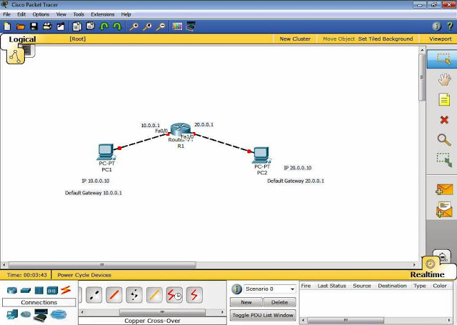](http://1.bp.blogspot.com/-0FdyvEBbqhM/Ulen3fSfwtI/AAAAAAAAAHc/2zUWz3lvpvQ/s1600/1.jpg)

**Step 2:** Click on PC 1->Config, assign Gateway in this case,10.0.0.1

[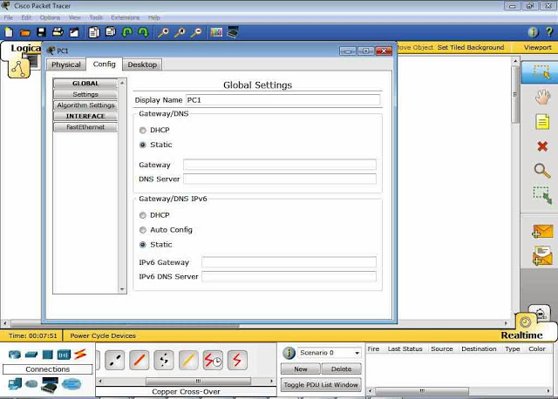](http://2.bp.blogspot.com/-F5xt8nYhBv4/Ulen20RaNWI/AAAAAAAAAHY/XM9InOQY6Ss/s1600/2.jpg)

[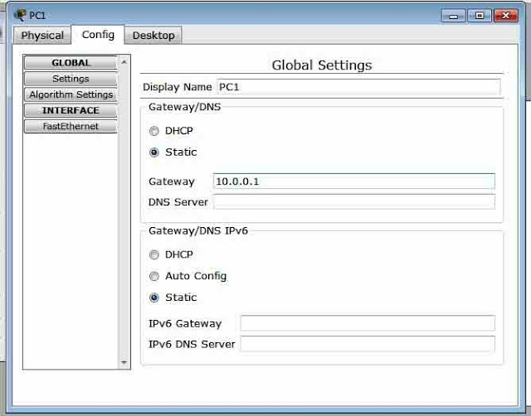](http://1.bp.blogspot.com/-9ngkNpsu2QY/Ulen8hChwQI/AAAAAAAAAHs/ypIsdWHTgzM/s1600/3.jpg)

**Step 3**:Click on Fastethernet and assign ip address and subnetmask,  
In this case ip 10.0.0.10 and subnet mask 255.0.0.0,Now close PC 1 window.Do like this for PC2 with appropriate ip and subnet mask.

[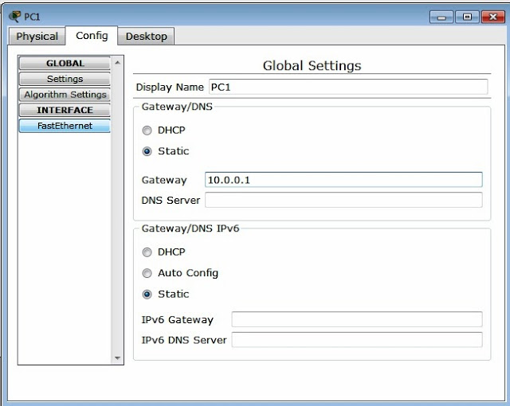](http://4.bp.blogspot.com/-HVQqDHz3C5I/Ulen8QNw1cI/AAAAAAAAAHo/V1m0ztoSS8I/s1600/4.jpg)

[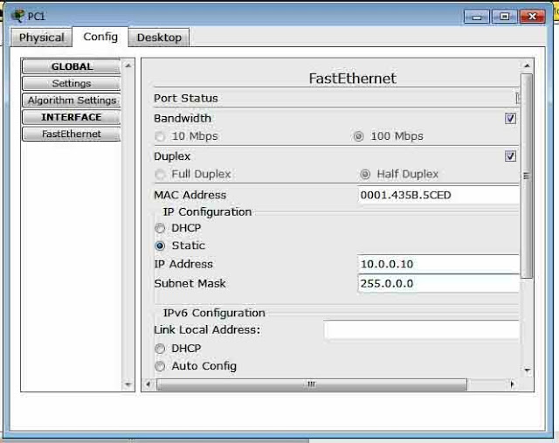](http://4.bp.blogspot.com/-eZ2zcaq9rp8/Ulen9JqBmSI/AAAAAAAAAH4/20cbMRyKTe8/s1600/5.jpg)

**Step 4**: Now Click on Router R1,then click on CLI(Commad Line Interface).  
  
You will see like this,"Continue with configuration dialog? [yes/no]:".Give "no" and Press enter.Now you will go to user mode,

**Step 5:** now give "enable" and press enter.Now you get into the Privileged Mode,now  type "configure terminal" and press enter to get into global configuration mode.  
  
**Step 6:** Now configure router interface with ip address and subnet mask then give no shutdown to make this interface and line protocol up(i.e. Carefully configure ip address with proper interfaces in this case f0/0 and f1/0,f is short form of fastethernet.  
  
**Router(config)#interface fastEthernet 0/0**  
**Router(config-if)#ip address 10.0.0.1 255.0.0.0**  
**Router(config-if)#no shutdown**  
**Router(config-if)#exit**  
  
Interface Line protocol on FastEthernet0/0, changed state to up  
  
**Router(config)#interface fastethernet 1/0**  
**Router(config-if)#ip address 20.0.0.1 255.0.0.0**  
**Router(config-if)#no shutdown**  
**Router(config-if)#exit**  
  
Interface Line protocol on FastEthernet1/0, changed state to up

[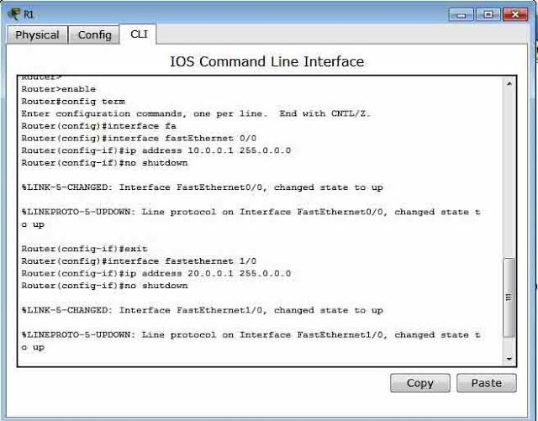](http://2.bp.blogspot.com/-eifEBZ9y6OQ/UleoBgcGfHI/AAAAAAAAAIA/xDbNq0JVWgo/s1600/7.jpg)

**Step 7:**Now lights on all ports become green from red.Now click on PC1->Desktop->Command Prompt.

**Step 8:**Now give this command "ping 20.0.0.10" and press enter.you will get,

[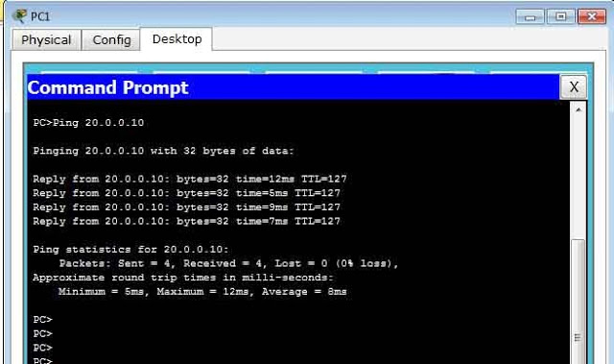](http://4.bp.blogspot.com/-GHANn6EtoYY/Ulen0mAvj8I/AAAAAAAAAHQ/wEsXlpsccDo/s1600/10.jpg)

connectivity between 10.0.0.10 and 20.0.0.10 is ok.Now PC1 communicates with PC2  
  
  
Another way of checking connectivity is,select "simple PDU packet" from right side of packet tracer and select source PC and Destination PC.You will get response at right bottom of the pacter tracer window.

# [**Understanding Ping Responses,Destination unreachable,Request timed out, Reply**](http://chennaicisco.blogspot.in/2013/02/understanding-ping-responsesdestination.html)

Here we are going to see ping responses network unreachable,request timed out,success with a simple topology by adding static route on each router step by step.  
  
**Step 1**:Create a topology like this and configure ip address as given below.

Only after configuring ip address u will get green link as shown below   
  
[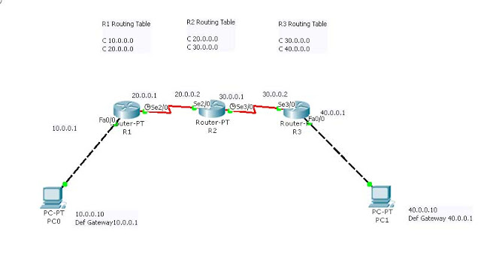](http://3.bp.blogspot.com/-7IFnmDiYqEw/UQyeFrKPvmI/AAAAAAAAAFk/WMhXzwi4SJ8/s1600/1.jpg)

**Step 2:**Routers only knows directly connected network,there is no static route added.Now, ping default gate way 10.0.0.1  from Host 10.0.0.10. we will get reply from 10.0.0.1.Because router knows 10.0.0.0 network.  
  
**ping 10.0.0.1**  
  
**PC>ping 10.0.0.1**  
 **Pinging 10.0.0.1 with 32 bytes of data:**  
 **Reply from 10.0.0.1: bytes=32 time=157ms TTL=255**  
**Reply from 10.0.0.1: bytes=32 time=16ms TTL=255**  
**Reply from 10.0.0.1: bytes=32 time=29ms TTL=255**  
**Reply from 10.0.0.1: bytes=32 time=31ms TTL=255**  
 **Ping statistics for 10.0.0.1:**  
**Packets: Sent = 4, Received = 4, Lost = 0 (0% loss),**  
**Approximate round trip times in milli-seconds:**  
**Minimum = 16ms, Maximum = 157ms, Average = 58ms**  
  
**Step 3**:Now ping host 40.0.0.10,we will get  
  
**PC>ping 40.0.0.10**  
 **Pinging 40.0.0.10 with 32 bytes of data:**  
 **Reply from 10.0.0.1: Destination host unreachable.**  
**Reply from 10.0.0.1: Destination host unreachable.**  
**Reply from 10.0.0.1: Destination host unreachable.**  
**Reply from 10.0.0.1: Destination host unreachable.**  
 **Ping statistics for 40.0.0.10:**  
**Packets: Sent = 4, Received = 0, Lost = 4 (100% loss),**

Because Router R1 doesn't know about the network 40.0.0.0.So we will get reply from 10.0.0.1 destination host unreachable.Check rouing table of R1 by giving command

**R1#show ip route**

**Codes: C - connected, S - static, I - IGRP, R - RIP, M - mobile, B - BGP**

**D - EIGRP, EX - EIGRP external, O - OSPF, IA - OSPF inter area**

**N1 - OSPF NSSA external type 1, N2 - OSPF NSSA external type 2**

**E1 - OSPF external type 1, E2 - OSPF external type 2, E - EGP**

**i - IS-IS, L1 - IS-IS level-1, L2 - IS-IS level-2, ia - IS-IS inter area**

**\* - candidate default, U - per-user static route, o - ODR**

**P - periodic downloaded static route**

**Gateway of last resort is not set**

**C    10.0.0.0/8 is directly connected, FastEthernet0/0**

**C    20.0.0.0/8 is directly connected, Serial2/0**

**Step 4**:Add static route to Router R1 for the network 40.0.0.0  
  
**R1(config)#ip route 40.0.0.0 255.0.0.0 20.0.0.2**  
  
Now,Packets that came to Router R1 for the network 40.0.0.0 will be forwarded to 20.0.0.2  
  
Check Routing table of R1 by giving command,  
  
**R1#show ip route**  
**Codes: C - connected, S - static, I - IGRP, R - RIP, M - mobile, B - BGP**  
**D - EIGRP, EX - EIGRP external, O - OSPF, IA - OSPF inter area**  
**N1 - OSPF NSSA external type 1, N2 - OSPF NSSA external type 2**  
**E1 - OSPF external type 1, E2 - OSPF external type 2, E - EGP**  
**i - IS-IS, L1 - IS-IS level-1, L2 - IS-IS level-2, ia - IS-IS inter area**  
**\* - candidate default, U - per-user static route, o - ODR**  
**P - periodic downloaded static route**  
 **Gateway of last resort is not set**  
 **C    10.0.0.0/8 is directly connected, FastEthernet0/0**  
**C    20.0.0.0/8 is directly connected, Serial2/0**  
**S    40.0.0.0/8 [1/0] via 20.0.0.2**  
  
**Step 5**:Now ping ip address  20.0.0.1,that is connected to Router R1 by giving command

**PC>ping 20.0.0.1**

**Pinging 20.0.0.1 with 32 bytes of data:**

**Reply from 20.0.0.1: bytes=32 time=31ms TTL=255**

**Reply from 20.0.0.1: bytes=32 time=16ms TTL=255**

**Reply from 20.0.0.1: bytes=32 time=32ms TTL=255**

**Reply from 20.0.0.1: bytes=32 time=31ms TTL=255**

**Ping statistics for 20.0.0.1:**

**Packets: Sent = 4, Received = 4, Lost = 0 (0% loss),**

**Approximate round trip times in milli-seconds:**

**Minimum = 16ms, Maximum = 32ms, Average = 27ms**

We get reply from 20.0.0.1 because router R1 knows directly connected network.  
  
**Step 6:**Now ping ip address 20.0.0.2  
  
**PC>ping 20.0.0.2**  
**Pinging 20.0.0.2 with 32 bytes of data:**  
**Request timed out.**  
**Request timed out.**  
**Request timed out.**  
**Request timed out.**  
**Ping statistics for 20.0.0.2:**  
**Packets: Sent = 4, Received = 0, Lost = 4 (100% loss),**  
  
Router R2 doesn't know about the network 10.0.0.0.So we can't get reply from R2.Now add static route to router R2 for network 10.0.0.0  .Check routing table of R2  
  
**R2#show ip route**  
**Codes: C - connected, S - static, I - IGRP, R - RIP, M - mobile, B - BGP**  
**D - EIGRP, EX - EIGRP external, O - OSPF, IA - OSPF inter area**  
**N1 - OSPF NSSA external type 1, N2 - OSPF NSSA external type 2**  
**E1 - OSPF external type 1, E2 - OSPF external type 2, E - EGP**  
**i - IS-IS, L1 - IS-IS level-1, L2 - IS-IS level-2, ia - IS-IS inter area**  
**\* - candidate default, U - per-user static route, o - ODR**  
**P - periodic downloaded static route**  
 **Gateway of last resort is not set**  
 **C    20.0.0.0/8 is directly connected, Serial2/0**  
**C    30.0.0.0/8 is directly connected, Serial3/**

**Step 7**:Add Static route to network 10.0.0.0 in R2

**R2(config)#ip route 10.0.0.0 255.0.0.0 20.0.0.1**

**R2#show ip route**

**Codes: C - connected, S - static, I - IGRP, R - RIP, M - mobile, B - BGP**

**D - EIGRP, EX - EIGRP external, O - OSPF, IA - OSPF inter area**

**N1 - OSPF NSSA external type 1, N2 - OSPF NSSA external type 2**

**E1 - OSPF external type 1, E2 - OSPF external type 2, E - EGP**

**i - IS-IS, L1 - IS-IS level-1, L2 - IS-IS level-2, ia - IS-IS inter area**

**\* - candidate default, U - per-user static route, o - ODR**

**P - periodic downloaded static route**

**Gateway of last resort is not set**

**Z    10.0.0.0/8 [1/0] via 20.0.0.1**

**C    20.0.0.0/8 is directly connected, Serial2/0**

**C    30.0.0.0/8 is directly connected, Serial3/0**

**Step 8**:Now ,ping 20.0.0.2 we get

**PC>ping 20.0.0.2**

**Pinging 20.0.0.2 with 32 bytes of data:**

**Reply from 20.0.0.2: bytes=32 time=63ms TTL=254**

**Reply from 20.0.0.2: bytes=32 time=62ms TTL=254**

**Reply from 20.0.0.2: bytes=32 time=62ms TTL=254**

**Reply from 20.0.0.2: bytes=32 time=62ms TTL=254**

**Ping statistics for 20.0.0.2:**

**Packets: Sent = 4, Received = 4, Lost = 0 (0% loss),**

**Approximate round trip times in milli-seconds:**

**Minimum = 62ms, Maximum = 63ms, Average = 62ms**

**After that, ping 40.0.0.10**

**PC>ping 40.0.0.10**

**Pinging 40.0.0.10 with 32 bytes of data:**

**Reply from 20.0.0.2: Destination host unreachable.**

**Reply from 20.0.0.2: Destination host unreachable.**

**Reply from 20.0.0.2: Destination host unreachable.**

**Reply from 20.0.0.2: Destination host unreachable.**

**Ping statistics for 40.0.0.10:**

**Packets: Sent = 4, Received = 0, Lost = 4 (100% loss),**

**Step 9**:We get reply from 20.0.0.2 as Destination host unreachable.So ,we have to add 40.0.0.0 network to R2

**R2(config)#ip route 40.0.0.0 255.0.0.0 30.0.0.2**

**R2#show ip route**

**Codes: C - connected, S - static, I - IGRP, R - RIP, M - mobile, B - BGP**

**D - EIGRP, EX - EIGRP external, O - OSPF, IA - OSPF inter area**

**N1 - OSPF NSSA external type 1, N2 - OSPF NSSA external type 2**

**E1 - OSPF external type 1, E2 - OSPF external type 2, E - EGP**

**i - IS-IS, L1 - IS-IS level-1, L2 - IS-IS level-2, ia - IS-IS inter area**

**\* - candidate default, U - per-user static route, o - ODR**

**P - periodic downloaded static route**

**Gateway of last resort is not set**

**S    10.0.0.0/8 [1/0] via 20.0.0.1**

**C    20.0.0.0/8 is directly connected, Serial2/0**

**C    30.0.0.0/8 is directly connected, Serial3/0**

**S    40.0.0.0/8 [1/0] via 30.0.0.2**

**Step 10:**  Ping 30.0.0.1 and see what we get,

**PC>ping 30.0.0.1**

**Pinging 30.0.0.1 with 32 bytes of data:**

**Reply from 10.0.0.1: Destination host unreachable.**

**Reply from 10.0.0.1: Destination host unreachable.**

**Reply from 10.0.0.1: Destination host unreachable.**

**Reply from 10.0.0.1: Destination host unreachable.**

**Ping statistics for 30.0.0.1:**

**Packets: Sent = 4, Received = 0, Lost = 4 (100% loss),**

**Step 11**:  Add static route to Router R1 for the network 30.0.0.0

**R1(config)#ip route 30.0.0.0 255.0.0.0 20.0.0.2**

Check Routing table of Router R1,

**R1#show ip route**

**Codes: C - connected, S - static, I - IGRP, R - RIP, M - mobile, B - BGP**

**D - EIGRP, EX - EIGRP external, O - OSPF, IA - OSPF inter area**

**N1 - OSPF NSSA external type 1, N2 - OSPF NSSA external type 2**

**E1 - OSPF external type 1, E2 - OSPF external type 2, E - EGP**

**i - IS-IS, L1 - IS-IS level-1, L2 - IS-IS level-2, ia - IS-IS inter area**

**\* - candidate default, U - per-user static route, o - ODR**

**P - periodic downloaded static route**

**Gateway of last resort is not set**

**C    10.0.0.0/8 is directly connected, FastEthernet0/0**

**C    20.0.0.0/8 is directly connected, Serial2/0**

**S    30.0.0.0/8 [1/0] via 20.0.0.2**

**S    40.0.0.0/8 [1/0] via 20.0.0.2**

Now , ping 30.0.0.1,

**PC>ping 30.0.0.1**

**Pinging 30.0.0.1 with 32 bytes of data:**

**Reply from 30.0.0.1: bytes=32 time=63ms TTL=254**

**Reply from 30.0.0.1: bytes=32 time=62ms TTL=254**

**Reply from 30.0.0.1: bytes=32 time=62ms TTL=254**

**Reply from 30.0.0.1: bytes=32 time=63ms TTL=254**

**Ping statistics for 30.0.0.1:**

**Packets: Sent = 4, Received = 4, Lost = 0 (0% loss),**

**Approximate round trip times in milli-seconds:**

**Minimum = 62ms, Maximum = 63ms, Average = 62ms**

**Step 12**:  Ping 30.0.0.2 and see what we will get,

**PC>ping 30.0.0.2**

**Pinging 30.0.0.2 with 32 bytes of data:**

**Request timed out.**

**Request timed out.**

**Request timed out.**

**Request timed out.**

**Ping statistics for 30.0.0.2:**

**Packets: Sent = 4, Received = 0, Lost = 4 (100% loss),**

**Router R3 doesn't know about the network 10.0.0.0.**

**Step 13**:Add network 10.0.0.0 &20.0.0.0 by using static route command.

**R3(config)#ip route 10.0.0.0 255.0.0.0 30.0.0.1**

**R3(config)#ip route 20.0.0.0 255.0.0.0 30.0.0.1**

**R3#show ip route**

**Codes: C - connected, S - static, I - IGRP, R - RIP, M - mobile, B - BGP**

**D - EIGRP, EX - EIGRP external, O - OSPF, IA - OSPF inter area**

**N1 - OSPF NSSA external type 1, N2 - OSPF NSSA external type 2**

**E1 - OSPF external type 1, E2 - OSPF external type 2, E - EGP**

**i - IS-IS, L1 - IS-IS level-1, L2 - IS-IS level-2, ia - IS-IS inter area**

**\* - candidate default, U - per-user static route, o - ODR**

**P - periodic downloaded static route**

**Gateway of last resort is not set**

**S    10.0.0.0/8 [1/0] via 30.0.0.1**

**S    10.0.0.0/8 [1/0] via 30.0.0.1**

**C    30.0.0.0/8 is directly connected, Serial3/0**

**C    40.0.0.0/8 is directly connected, FastEthernet0/0**

Now ,ping 40.0.0.10  
**PC>ping 40.0.0.10**  
**Pinging 40.0.0.10 with 32 bytes of data:**  
**Reply from 40.0.0.10: bytes=32 time=125ms TTL=125**  
**Reply from 40.0.0.10: bytes=32 time=110ms TTL=125**  
**Reply from 40.0.0.10: bytes=32 time=110ms TTL=125**  
**Reply from 40.0.0.10: bytes=32 time=125ms TTL=125**  
 **Ping statistics for 40.0.0.10:**  
**Packets: Sent = 4, Received = 4, Lost = 0 (0% loss),**  
**Approximate round trip times in milli-seconds:**  
**Minimum = 110ms, Maximum = 125ms, Average = 117ms**

Finally we get reply from 40.0.0.10 .

**Step 14**:  Now go host 40.0.0.10 and ping host 10.0.0.10 and check whether we can ping or not..

**PC>ping 10.0.0.10**

**Pinging 10.0.0.10 with 32 bytes of data:**

**Reply from 10.0.0.10: bytes=32 time=109ms TTL=125**

**Reply from 10.0.0.10: bytes=32 time=125ms TTL=125**

**Reply from 10.0.0.10: bytes=32 time=125ms TTL=125**

**Reply from 10.0.0.10: bytes=32 time=125ms TTL=125**

**Ping statistics for 10.0.0.10:**

**Packets: Sent = 4, Received = 4, Lost = 0 (0% loss),**

**Approximate round trip times in milli-seconds:**

**Minimum = 109ms, Maximum = 125ms, Average = 121ms**

Three types of reply we got

Reply

Destination host unreachable

Request timed out

In Router,

For,Reply-     !!!!!

       Destination host unreachable-   UUUUU

       Request timed out-     .......

**Destination Host Unreachable**

This message indicates one of two problems: either the local system has no route to the desired destination, or a remote router reports that it has no route to the destination.

If the message is simply "Destination Host Unreachable," then there is no route from the local system, and the packets to be sent were never put on the wire.

If the message is "Reply From < IP address >: Destination Host Unreachable," then the routing problem occurred at a remote router, whose address is indicated by the "< IP address >" field.

**Request Timed Out**

This message indicates that no Echo Reply messages were received within the default time of 1 second. This can be due to many different causes; the most common include network congestion, failure of the ARP request, packet filtering, routing error, or a silent discard.

**3** [**How to Configure Default Route to the Routers**](http://chennaicisco.blogspot.in/2013/01/how-to-configure-default-route-to.html)

Here we are going to see how to configure default route in a routers ,we can configure default route for stub network. i.e dead end router we can point an ip address  or exit interface for all packets that came to that router.Here we go..

Steps:

**Step 1**:Here, in our topology we have two stub network .

[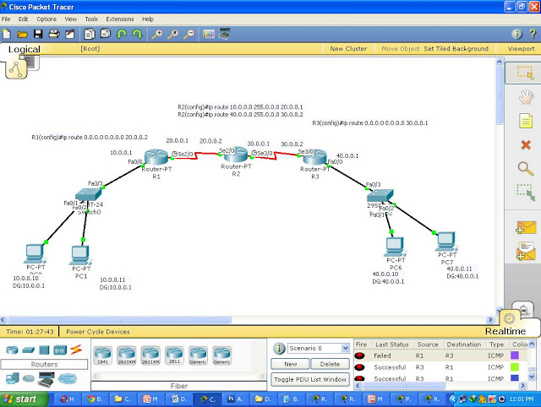](http://3.bp.blogspot.com/-xpI9GvyEUz8/UQN4Y7wQ7qI/AAAAAAAAACU/r-or84EAuPA/s1600/f.jpg)

Apply basic configurations ip address to all interfaces and pc's

**Step 2**: Configure static route on R2 to route packets for 10.0.0.0 and 40.0.0.0 networks like this

R2(config)#ip route Destination Network| Destination N/W SubnetMask |Next Hop Address or Exit Interface

**In Router R2**

**R2(config)#ip route 10.0.0.0 255.0.0.0 20.0.0.1**

**R2(config)#ip route 40.0.0.0 255.0.0.0 30.0.0.2**

**Step 3**: Now we are going to configure default route on R1 and R3.So the routers forward packets to assigned ip address next hop address or exit interface

**In Router R1**

**R1(config)#ip route 0.0.0.0 0.0.0.0 20.0.0.2**

**In Router R3**

**R3(config)#ip route 0.0.0.0 0.0.0.0 30.0.0.1**

Here, 0.0.0.0 0.0.0.0 represents any network any subnetmask. i.e any packet that came to router R1 will be forwarded to next hop address 20.0.0.2.Now check the routing table of R1

**R1#show ip route**

**Codes: C - connected, S - static, I - IGRP, R - RIP, M - mobile, B - BGP**

**D - EIGRP, EX - EIGRP external, O - OSPF, IA - OSPF inter area**

**N1 - OSPF NSSA external type 1, N2 - OSPF NSSA external type 2**

**E1 - OSPF external type 1, E2 - OSPF external type 2, E - EGP**

**i - IS-IS, L1 - IS-IS level-1, L2 - IS-IS level-2, ia - IS-IS inter area**

**\* - candidate default, U - per-user static route, o - ODR**

**P - periodic downloaded static route**

**Gateway of last resort is 20.0.0.2 to network 0.0.0.0**

**C    10.0.0.0/8 is directly connected, FastEthernet0/0**

**C    20.0.0.0/8 is directly connected, Serial2/0**

**S*   0.0.0.0/0 [1/0] via 20.0.0.2**

**is directly connected, Serial2/0**

S* represents Static default route .Now Ping from 10.0.0.10 to 40.0.0.10 you will get reply as

**PC>ping 40.0.0.10**

**Pinging 40.0.0.10 with 32 bytes of data:**

**Reply from 40.0.0.10: bytes=32 time=141ms TTL=125**

**Reply from 40.0.0.10: bytes=32 time=187ms TTL=125**

**Reply from 40.0.0.10: bytes=32 time=172ms TTL=125**

**Reply from 40.0.0.10: bytes=32 time=125ms TTL=125**

**Ping statistics for 40.0.0.10:**

**Packets: Sent = 4, Received = 4, Lost = 0 (0% loss),**

**Approximate round trip times in milli-seconds:**

**Minimum = 125ms, Maximum = 187ms, Average = 156ms**

we can also configure exit interface instead of next hop address like this

**R1(config)#ip route 0.0.0.0 0.0.0.0 serial 2/0**

**R3(config)#ip route 0.0.0.0 0.0.0.0 serial 3/0**

Administrative distance if configure with next hop address is 1,for exit interface is 0....

# [**How to Configure DHCP in Cisco Router Using Packet Tracer and Gns3**](http://chennaicisco.blogspot.in/2013/10/how-to-configure-dhcp-in-cisco-router.html)

Step 1:Create a topology like this,

[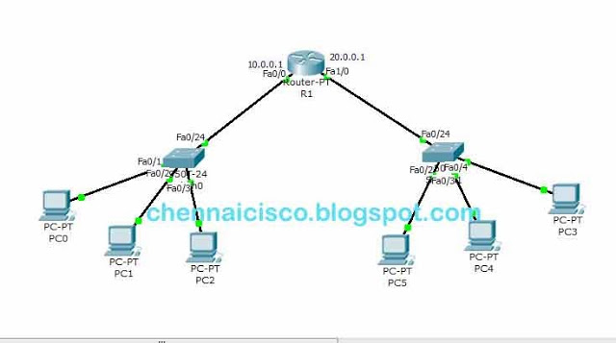](http://3.bp.blogspot.com/-hoNCcyRm6I0/Ul5Wb-2lKII/AAAAAAAAALc/3yqrMlUWJyg/s1600/DHCp+in+router+interface+1.jpg)

**Step 2:** Configure router interface fastethernet0/0 and fastethernet  
  
1/0 with ip address.  
  
**R1#config t**  
**R1(config)#interface fastethernet 0/0**  
**R1(config-if)#ip address 10.0.0.1 255.0.0.0**  
**R1(config-if)#no shutdown**  
 **R1(config-if)#exit**  
**R1(config)#interface fastethernet 1/0**  
**R1(config-if)#ip address 20.0.0.1 255.0.0.0**  
**R1(config-if)#no shutdown**  
**R1(config-if)#exit**  
  
**Step 3**: Configure DHCP pool for the network 10 and 20,  
  
In Router R1,Global Configuration mode,  
  
R1(config)#service dhcp  
  
This command is to enable the dhcp server on a router. Routers in packet tracer won't accept this command.By default dhcp will be running on router so skip 'service dhcp' command if you are configuring dhcp in packet tracer,just create a network pool for the network it will work.Use this in real time or other simulators like gns3.  
  
R1(config)#ip dhcp pool 10network         "where '10network' is the pool name we can use what ever we  
want.This command get us into the DHCP Configuration mode."  
  
R1(dhcp-config)#network 10.0.0.0 255.0.0.0        "It defines the network range to be leased"  
  
R1(dhcp-config)#dns-server 10.0.0.2       "Ip address for the dns server."  
  
R1(dhcp-config)#default-router 10.0.0.1       "Default gateway for this network."  
  
R1(dhcp-config)#exit  
  
**DHCP pool for 10 Network**  
 **R1(config)#ip dhcp pool 10network**  
**R1(dhcp-config)#network 10.0.0.0 255.0.0.0**  
**R1(dhcp-config)#dns-server 10.0.0.2**  
**R1(dhcp-config)#default-router 10.0.0.1**  
**R1(dhcp-config)#exit**  
 **DHCP pool for 20 Network**  
 **R1(config)#ip dhcp pool 20network**  
**R1(dhcp-config)#network 20.0.0.0 255.0.0.0**  
**R1(dhcp-config)#dns-server 10.0.0.2**  
**R1(dhcp-config)#default-router 20.0.0.1**  
**R1(dhcp-config)#exit**  
  
Now, Click on any of the PC->Desktop->ip configuration->Choose DHCP.Now PC will get an ip from DHCP server.

[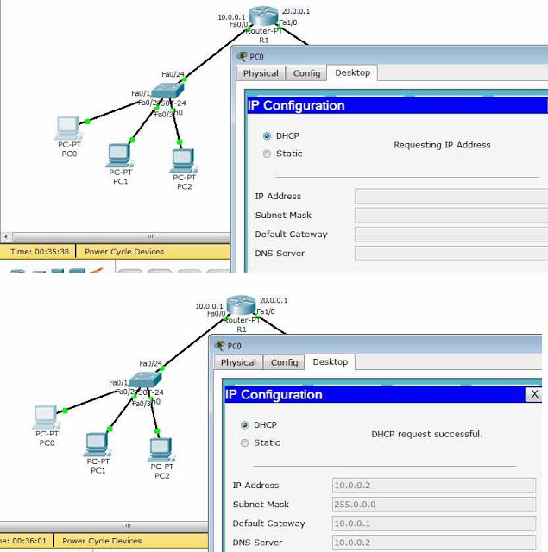](http://3.bp.blogspot.com/-xaaMe6Fdp7c/Ul5WbzrpWjI/AAAAAAAAALg/BCGFu0Q8MVw/s1600/DHCp+in+router+interface+fin.jpg)

Few more command We can use, but we can't configure this in packet tracer.Use gns3 simulator for this.  
R1(dhcp-config)#netbios-server x.x.x.x 'where x.x.x.x is ip address of netbios server.  
R1(dhcp-config)#lease x   'where X is the number it sets the lease time,by default 1 (i.e. one day).  
R1(dhcp-config)#ip dhcp excluded address x.x.x.x x.x.x.x   'Range of ip address excluded from the pool it will not be leased to the clients'.  
R1(dhcp-config)#ip dhcp excluded address x.x.x.x    'To exclude only one ip address from the range of ip address'.  
  
**Ex.**  
**R1(dhcp-config)#netbios-server 10.0.0.2**  
**R1(dhcp-config)#lease 2**  
**R1(dhcp-config)#ip dhcp excluded address 10.0.0.1 10.0.0.10**  
**R1(dhcp-config)#ip dhcp excluded address 10.0.0.35**

# [**How to configure DHCP within a LAN in a packet Tracer**](http://chennaicisco.blogspot.in/2013/10/how-to-configure-dhcp-within-lan-in_7137.html)

Here,we are going to see how to configure DHCP within a LAN in a packet tracer,  
DHCP-Dynamic Host Configuration Protocol  
DHCP Proces,(DORA)  
 =>Discover( Client discovers the DHCP Server for Ip request )  
 =>Offer ( DHCP servers offers ip to a client and it will wait for the request from cleint  
 =>Request ( Client reply for requesting offered ip address from dhcp server,sometimes there will be                  more dhcp servers.So,client receives offer from multiple servers.client will reply for only one                          offer.So, other offers will be canceled and replaced in a pool.)  
 =>Acknowledgement (Final step from server sending all infromation to client like DNS,Default                          Gateway,tftp,domain name,...  )  
  
DHCP Server uses Port 67,Client uses port 68  
It uses UDP(User Datagram Protocol).  
  
**Step 1:**Create a LAN like this,

[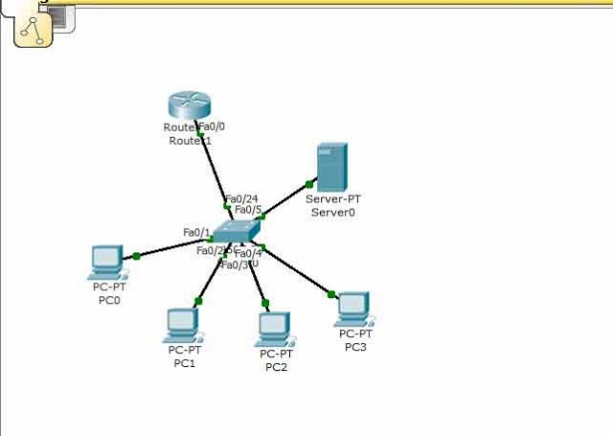](http://1.bp.blogspot.com/-VfUotqjFHRU/UludcVIzPJI/AAAAAAAAAJc/f6NQpOBY_Hw/s1600/1.jpg)

# **Step 2:**Configure router interface with ip 10.0.0.1 and subnet mask 255.0.0.0 Router>enable Router#config t Router(config)#interface fastethernet0/0 Router(config-if)#ip address 10.0.0.1 255.0.0.0 Router(config-if)#no shutdown Router(config-if)#exit Router(config)# **Step 3:**click on server-> config, then assign gateway in our example 10.0.0.1 **Step 4:**Then Click on Fastethernet and assign ip address and subnet mask.I am going to use 10.0.0.2 and subnet mask 255.0.0.0 for our server. **Step 5:** Click on DHCP,there you can see default pool**, step 6:**Just give default gate way,here we are using 10.0.0.1. **Step 7:**DNS server,Just give our server ip address,10.0.0.2. **Step 8:**Then just edit start ip address.I am going to give 10.0.0.10 and subnet mask 255.0.0.0 **Step 9:**In Maximum Number of Users,Here we are using Class A Network so we can use 1,67,77,216 ip address.just give how many ip address you want in this pool.I am going to give 500 **Step 10:**Assign TFTP server ip address,just give our server ip address,10.0.0.2. **Step 11:** And click on save.That's it... [**Description: http://3.bp.blogspot.com/-422JFV3d0E4/UludlU7QT9I/AAAAAAAAAJk/gBHqAZTHIfg/s1600/2.jpg**](http://3.bp.blogspot.com/-422JFV3d0E4/UludlU7QT9I/AAAAAAAAAJk/gBHqAZTHIfg/s1600/2.jpg)

# **Step 12:**Now, Click on any of the PC-> then click on Desktop->Ip configuration,and Choose 'DHCP' wait for some time,if your dhcp request failed then try few more times.This is how you should get. [**Description: http://3.bp.blogspot.com/-vx6RW78GVBs/UludluP-KFI/AAAAAAAAAJo/HeKBalThaKc/s1600/fin.jpg**](http://3.bp.blogspot.com/-vx6RW78GVBs/UludluP-KFI/AAAAAAAAAJo/HeKBalThaKc/s1600/fin.jpg)

# [**How to Configure NAT with PAT Port Address Translation Using Packet Tracer**](http://chennaicisco.blogspot.in/2013/10/how-to-configure-nat-with-pat-port.html)

Here we are going to see how to configure NAT with PAT(Port Address Translation) using packet tracer in a cisco routers.  
  
**Step 1**:Create topology like this,

[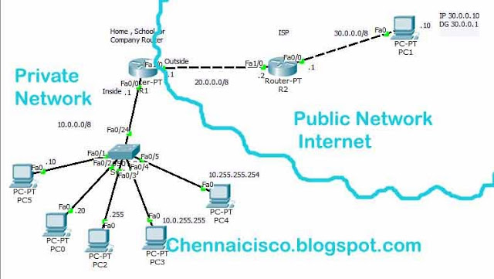](http://2.bp.blogspot.com/-frW8TSVZz-s/UnIwz0MtlJI/AAAAAAAAAPo/AocQ3-p2DYE/s1600/Dynamic++Network+address+translation.jpg)

**Step 2**: Configure ip address to all router interfaces and PC's like i have given in a topology.  
  
**In Router R1,global config mode**  
 **R1(config)#interface fastethernet 0/0**  
**R1(config-if)#ip address 10.0.0.1 255.0.0.0**  
**R1(config-if)#no shutdown**  
**R1(config-if)#exit**  
 **R1(config)#interface fastethernet 1/0**  
**R1(config-if)#ip address 20.0.0.1 255.0.0.0**  
**R1(config-if)#no shutdown**  
**R1(config-if)#exit**  
 **In Router R2,global config mode**  
 **R2(config)#interface fastethernet 1/0**  
**R2(config-if)#ip address 20.0.0.2 255.0.0.0**  
**R2(config-if)#no shutdown**  
**R2(config-if)#exit**  
 **R2(config)#interface fastethernet 0/0**  
**R2(config-if)#ip address 30.0.0.1 255.0.0.0**  
**R2(config-if)#no shutdown**  
**R2(config-if)#exit**  
  
  
**Step 3**:Access list Configuration for 10.0.0.0 network,I am going to configure standard access list for this.  
  
**In Router R1,global configuration mode**  
 **R1(config)#access-list 10 permit 10.0.0.0 0.255.255.255**  
  
  
  
**Step 4:**Here,interface fastethernet0/0 is inside and interface fastethernet1/0 is outside.  
  
**R1(config)#interface fastethernet0/0**  
**R1(config-if)#ip nat inside**  
**R1(config-if)#exit**  
 **R1(config)#interface fastethernet1/0**  
**R1(config-if)#ip nat outside**  
**R1(config-if)#exit**  
  
**Step 5**:configure the NAT PAT with access list 10,  
  
**R1(config)#ip nat inside source list 10 interface fastethernet1/0**  
 **(or)**  
**R1(config)#ip nat inside source list 10 interface fastethernet1/0 overload**

 First is command will not force the router to use ports but in Second command 'Overload' will force the router to use ports from 1024-65535 for the translation.So,this is called as Port Address Translation.  
  
**Step 6**: Now,Configure static default route to forward all packets to any network to next hop 20.0.0.2 or exit interface.  
  
  
**R1(config)#ip route 0.0.0.0 0.0.0.0 20.0.0.2**  
 **(or)**  
**R1(config)#ip route 0.0.0.0 0.0.0.0 fastethernet1/0**  
  
 Here,this both command do the same but, Distance metric for this network by default is 1and for the second .Both will forward packets to 20.0.0.2 that goes to any destination address.  
  
  
**Step 7:** Now go router R1 and give this command in privileged mode,  
  
**R1#debug ip nat**  
  
             we can see translation when PC accessing host in public network.  
  
**Step 8:**Click on PC->Desktop->command prompt->ping 30.0.0.10 and press 'enter'.Do this in all 5PC's immediately then only router use the ports from 1024-65,535 and go check router R1 to see translation.I have got,

[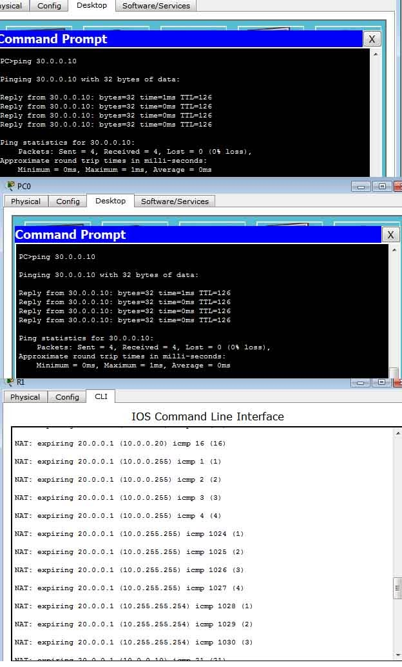](http://3.bp.blogspot.com/-08GHmOwiSiw/UnIw2dHVsEI/AAAAAAAAAPw/FqmfBBl9_cw/s1600/Responses.jpg)

NAT translations in Router R1,i will show you some translations alone.  
  
**NAT*: s=30.0.0.10, d=20.0.0.1->10.0.0.255 [24]**  
**NAT: s=10.0.0.255->20.0.0.1, d=30.0.0.10 [4]**  
**NAT*: s=30.0.0.10, d=20.0.0.1->10.0.0.255 [25]**  
**NAT: s=10.0.255.255->20.0.0.1, d=30.0.0.10 [1]**  
  
Router will wait 30 seconds after that translations will be expired and ip address will be available again  
  
**NAT: expiring 20.0.0.1 (10.0.255.255) icmp 1024 (1)**  
**NAT: expiring 20.0.0.1 (10.0.255.255) icmp 1025 (2)**  
**NAT: expiring 20.0.0.1 (10.0.255.255) icmp 1026 (3)**  
**NAT: expiring 20.0.0.1 (10.0.255.255) icmp 1027 (4)**  
**NAT: expiring 20.0.0.1 (10.255.255.254) icmp 1028 (1)**  
**NAT: expiring 20.0.0.1 (10.255.255.254) icmp 1029 (2)**  
**NAT: expiring 20.0.0.1 (10.255.255.254) icmp 1030 (3)**  
**NAT: expiring 20.0.0.1 (10.0.0.10) icmp 21 (21)**  
**NAT: expiring 20.0.0.1 (10.255.255.254) icmp 1031 (4)**  
**NAT: expiring 20.0.0.1 (10.0.0.10) icmp 22 (22)**  
  
**Troubleshooting commands,**  
 **R1#show ip nat translations**  
**R1#show ip nat statistics**  
**R1#clear ip nat translation \***  
**R1#show running-config**  
**R1#show ip route**

# [**How to Configure Static NAT using Packet Tracer and GNS3 in a Cisco Router**](http://chennaicisco.blogspot.in/2013/10/how-to-configure-static-nat-using.html)

# Here,we are going to see how to configure static NAT using packet tracer. **Step 1:Create topology like this,**

[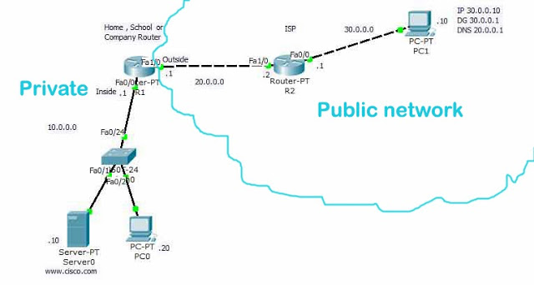](http://2.bp.blogspot.com/-C8XeLJB-rzM/Um9xO_Jl20I/AAAAAAAAAPA/h1IASitgQbs/s1600/static+network+address+translation.jpg)

**Step 2**:Configure router and host with ip address like i have given in a topology.  
  
**In Router R1,global config mode**  
 **R1(config)#interface fastethernet 0/0**  
**R1(config-if)#ip address 10.0.0.1 255.0.0.0**  
**R1(config-if)#no shutdown**  
**R1(config-if)#exit**

**R1(config)#interface fastethernet 1/0**  
**R1(config-if)#ip address 20.0.0.1 255.0.0.0**  
**R1(config-if)#no shutdown**  
**R1(config-if)#exit**  
 **In Router R2,global config mode**  
 **R2(config)#interface fastethernet 1/0**  
**R2(config-if)#ip address 20.0.0.2 255.0.0.0**  
**R2(config-if)#no shutdown**  
**R2(config-if)#exit**  
 **R2(config)#interface fastethernet 0/0**  
**R2(config-if)#ip address 30.0.0.1 255.0.0.0**  
**R2(config-if)#no shutdown**  
**R2(config-if)#exit**  
  
**Step 3**:Register a domain www.cisco.com with public ip address(20.0.0.1) that we bought from internet service provider.To do that click on server->Config->DNS  
  
  
 Name should be 'www.cisco.com'  
 Address should be '20.0.0.1' .Then click on add and save.  
  
[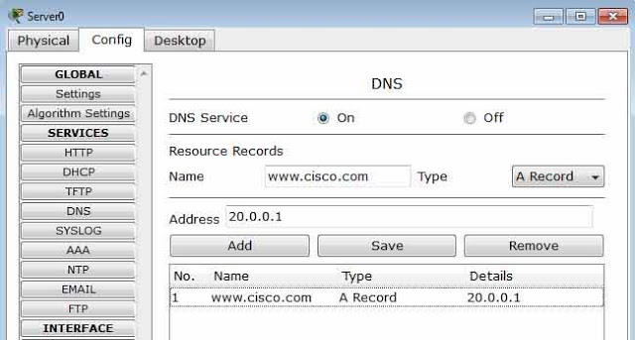](http://4.bp.blogspot.com/-LrYyGIrgzJc/Um9p9qMB6UI/AAAAAAAAAOc/UJcaZ92pId8/s1600/server.jpg)  
  
**Step 4**: Configure host 30.0.0.10 that is in public network with ip address ,default gateway,dns server ip address.To do this,  
  
 Click on PC->Desktop->Ip Configuration  
  
 Ip Address      ->30.0.0.10  
 Subnet Mask     ->255.0.0.0  
 Default Gateway ->30.0.0.1  
 DNS Server      ->20.0.0.1  
  
 Here,DNS server is present in our local area network,just give our public ip 20.0.0.1  NAT will do translation that packets comes to 20.0.0.1 to 10.0.0.10.  
  
**Step 5:**Choose the interface for inside and outside,Here interface fastethernet 0/0 as 'Inside' and interface fastethernet1/0 as 'Ouside' .Configure this two interface with this command,  
  
**In Router R1,global config mode**  
 **R1(config)#interface fastethernet 0/0**  
**R1(config-if)#ip nat inside**  
**R1(config-if)#exit**  
 **R1(config)#interfac fastethernet 1/0**  
**R1(config-if)#ip nat outside**  
**R1(config-if)#exit**  
  
  
**Step 6:**Configure Static NAT in Router R1 to translate 10.0.0.10(Private) as 20.0.0.1(Public).When host replies for the request NAT will undo the translation.  
  
**In Router R1,global config mode**  
 **R1(config)#ip nat inside source static 10.0.0.10 20.0.0.1**  
  
**Step 7**:Configure a Static default route to Router R1 to forward packets to 20.0.0.2 (next hop address) for the packets to any network.  
  
**In Router R1,global config mode**  
 **R1(config)#ip route 0.0.0.0 0.0.0.0 20.0.0.2**  
  
**Step 8:**Now give this command to see translation process when host request server.  
  
**In privileged mode,**  
  
**R1#debug ip nat**  
           You will get this 'IP NAT debugging is on'.This is to see the translation process when host 30.0.0.10 request 20.0.0.1 for web page.  
  
**Step 9:**Now, Click on host 30.0.0.10->Desktop->web Browser.Now give 'www.cisco.com' in address bar and Press Enter.Now we get a web page from server(10.0.0.10).Because,the ISP routers knows where the public ip addresses were present.And go to router R1 to see Translation process.  
  
 Process when we request a web page in web browser,  
 Host request DNS server asking for the ip address for the domain www.cisco.com  
 Host gets a ip address for that domain from DNS.Now host knows the ip for that domain. It will request a service that present 20.0.0.1:80.When request reached 20.0.0.1 router will translate to 10.0.0.10 .For the reply router will undo the translation,  
  
  
[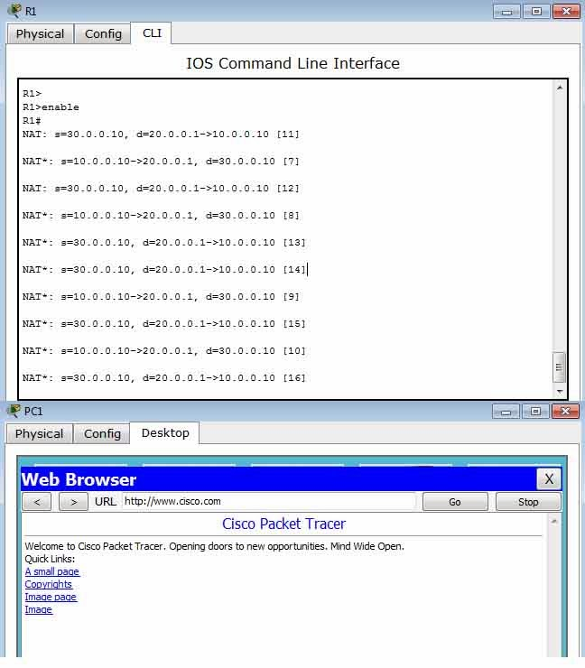](http://4.bp.blogspot.com/-70c2keLEJS4/Um9p8SLor2I/AAAAAAAAAOU/Pfy1hatIzz0/s1600/Responses.jpg)  
  
  
Translation process in router R1,  
 **R1#**  
**NAT: s=30.0.0.10, d=20.0.0.1->10.0.0.10 [11]**  
**NAT*: s=10.0.0.10->20.0.0.1, d=30.0.0.10 [7]**  
**NAT: s=30.0.0.10, d=20.0.0.1->10.0.0.10 [12]**  
**NAT*: s=10.0.0.10->20.0.0.1, d=30.0.0.10 [8]**  
**NAT*: s=30.0.0.10, d=20.0.0.1->10.0.0.10 [13]**  
**NAT*: s=30.0.0.10, d=20.0.0.1->10.0.0.10 [14]**  
**NAT*: s=10.0.0.10->20.0.0.1, d=30.0.0.10 [9]**  
**NAT*: s=30.0.0.10, d=20.0.0.1->10.0.0.10 [15]**  
 **NAT*: s=10.0.0.10->20.0.0.1, d=30.0.0.10 [10]**  
**NAT*: s=30.0.0.10, d=20.0.0.1->10.0.0.10 [16]**  
Trouble shooting commands,  
  
**R1#show ip nat translations**  
**Pro  Inside global     Inside local       Outside local      Outside global**  
**---  20.0.0.1          10.0.0.10          ---                ---**  
**tcp 20.0.0.1:80        10.0.0.10:80       30.0.0.10:1025     30.0.0.10:1025**  
**tcp 20.0.0.1:80        10.0.0.10:80       30.0.0.10:1026     30.0.0.10:1026**  
  
**R1#show ip nat statistics**  
**Total translations: 3 (1 static, 2 dynamic, 2 extended)**  
**Outside Interfaces: FastEthernet1/0**  
**Inside Interfaces: FastEthernet0/0**  
**Hits: 18  Misses: 5**  
**Expired translations: 3**  
**Dynamic mappings:**  
 **R1#Clear ip nat translation \***

# [**How to Configure Dynamic NAT Using Pool of IP Address in Packet Tracer and GNS 3**](http://chennaicisco.blogspot.in/2013/10/how-to-configure-dynamic-nat-using-pool.html)

Here,we are going to configure dynamic NAT with Pool of Public ip Address range by using packet  
tracer.This type of Natting provides protection by hiding our real public ip address of our network.  
  
**Step 1:**Create topology like this,

[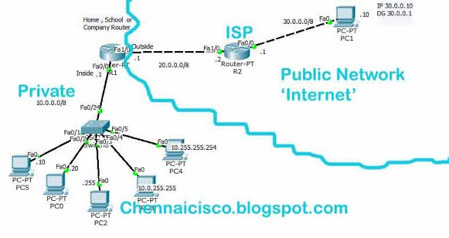](http://3.bp.blogspot.com/-wY_VZq2qvrs/UnIrPUeAoAI/AAAAAAAAAPU/fhV8pR_wJsQ/s1600/Dynamic+Network+address+translation+Address+pool+copy.jpg)

**Step 2**:Configure ip address to all router interfaces and PC's  
  
**In Router R1,global config mode**  
  
**R1(config)#interface fastethernet 0/0**  
**R1(config-if)#ip address 10.0.0.1 255.0.0.0**  
**R1(config-if)#no shutdown**  
**R1(config-if)#exit**  
 **R1(config)#interface fastethernet 1/0**  
**R1(config-if)#ip address 20.0.0.1 255.0.0.0**  
**R1(config-if)#no shutdown**  
**R1(config-if)#exit**  
 **In Router R2,global config mode**  
 **R2(config)#interface fastethernet 1/0**  
**R2(config-if)#ip address 20.0.0.2 255.0.0.0**  
**R2(config-if)#no shutdown**  
**R2(config-if)#exit**  
 **R2(config)#interface fastethernet 0/0**  
**R2(config-if)#ip address 30.0.0.1 255.0.0.0**  
**R2(config-if)#no shutdown**  
**R2(config-if)#exit**  
  
**Step 3**:Configure standard access list for the network 10.0.0.0  
  
**R1(config)#access-list 10 permit 10.0.0.0 0.255.255.255**  
  
  
**Step 4**:Choose interface for 'ip nat inside' and 'ip nat outside' command.Here, Interface fastethernet0/0 is inside and interface fastethernet1/0 is outside.  
  
**R1(config)#interface fastethernet0/0**  
**R1(config-if)#ip nat inside**  
**R1(config-if)#exit**  
 **R1(config)#interface fastethernet1/0**  
**R1(config-if)#ip nat outside**  
**R1(config-if)#exit**  
  
  
**Step 5:**Create a pool of address,I am going take range from 20.0.0.1 to 20.0.0.6.  
  
**R1(config)#ip nat pool publiciprange 20.0.0.1 20.0.0.6 netmask 255.255.255.248**  
  
 Here,'publiciprange' name we give for this range of ip address.we can give what ever we want.Here our router pulic ip address is 20.0.0.1 and subnetmask 255.0.0.0.The range of ip address we are using is 20.0.0.1 20.0.0.6 with subnetmask 255.255.255.248.So, this ip address range is different than ip address in router interface.So person in public network can't see the real public ip of our network 20.0.0.1. They can only see the range of ip addres with differnet subnetmask this is also one type of security for our network.  
  
**Step 6**:Configuring NAT with Pool 'publiciprange'.  
  
**R1(config)#ip nat inside source list 10 pool publiciprange**  
**Step 7**:configure static default route to forward all packets to any network to the next hop 20.0.0.2 or exit interface.  
  
**R1(config)#ip route 0.0.0.0 0.0.0.0 20.0.0.2**  
 **(or)**  
 **R1(config)#ip route 0.0.0.0 0.0.0.0 fastethernet1/0**  
  
            Here,this both command do the same but distance metric is differnet for the first type is 1 for the Second 0.  
  
**Step 8:**Now go router R1 and give this command in privileged mode,  
  
**R1#debug ip nat**  
 By this command, we can see the translation process in router.  
  
**Step 9**:Click on PC->Desktop->command prompt->ping 30.0.0.10 and press 'enter'.Do this in all 5PC's immediately and check router R1 to seetranslation.i have got,

[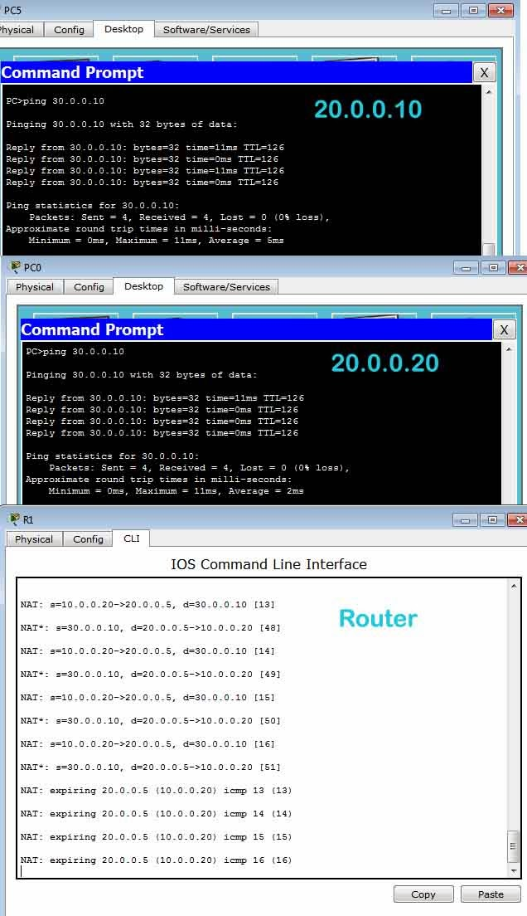](http://4.bp.blogspot.com/-7GQPM77-cwc/UnIrO0MIaII/AAAAAAAAAPQ/zSxthtdVz8Q/s1600/Responses.jpg)  
  
Translation in router R1,i will copy and paste some translations below  
**NAT: s=10.0.0.10->20.0.0.6, d=30.0.0.10 [9]**  
**NAT*: s=30.0.0.10, d=20.0.0.6->10.0.0.10 [32]**  
**NAT: s=10.0.0.10->20.0.0.6, d=30.0.0.10 [10]**  
**NAT*: s=30.0.0.10, d=20.0.0.6->10.0.0.10 [33]**  
**NAT: s=10.0.0.20->20.0.0.2, d=30.0.0.10 [9]**  
**NAT: s=10.0.0.10->20.0.0.6, d=30.0.0.10 [11]**  
**NAT*: s=30.0.0.10, d=20.0.0.6->10.0.0.10 [34]**  
**NAT: s=10.0.0.255->20.0.0.3, d=30.0.0.10 [9]**  
**NAT*: s=30.0.0.10, d=20.0.0.3->10.0.0.255 [35]**  
**NAT: s=10.0.0.10->20.0.0.6, d=30.0.0.10 [12]**  
**NAT*: s=30.0.0.10, d=20.0.0.6->10.0.0.10 [36]**  
**NAT: s=10.0.0.255->20.0.0.3, d=30.0.0.10 [10]**

Router will wait 30 seconds after that translations will be expired and ip address will be available again  
**NAT: expiring 20.0.0.6 (10.0.0.10) icmp 5 (5)**  
**NAT: expiring 20.0.0.6 (10.0.0.10) icmp 6 (6)**  
**NAT: expiring 20.0.0.2 (10.0.0.20) icmp 5 (5)**  
**NAT: expiring 20.0.0.6 (10.0.0.10) icmp 7 (7)**  
**NAT: expiring 20.0.0.6 (10.0.0.10) icmp 8 (8)**  
**NAT: expiring 20.0.0.3 (10.0.0.255) icmp 5 (5)**  
**NAT: expiring 20.0.0.3 (10.0.0.255) icmp 6 (6)**  
**NAT: expiring 20.0.0.3 (10.0.0.255) icmp 7 (7)**  
**NAT: expiring 20.0.0.4 (10.0.255.255) icmp 5 (5)**  
**NAT: expiring 20.0.0.3 (10.0.0.255) icmp 8 (8)**  
**NAT: expiring 20.0.0.4 (10.0.255.255) icmp 6 (6)**  
**NAT: expiring 20.0.0.2 (10.0.0.20) icmp 6 (6)**  
**NAT: expiring 20.0.0.4 (10.0.255.255) icmp 7 (7)**  
**Troubleshooting commands,**  
**R1#show ip nat translations**  
**R1#show ip nat statistics**  
**R1#clear ip nat translation \***  
**R1#show running-config**  
**R1#show ip route**

# **10.** [**How to configure RIP Routing Protocol in Routers**](http://chennaicisco.blogspot.in/2013/02/how-to-configure-rip-routing-protocol.html)

RIP-Routing Information Protocol

Routing Information Protocol is distance vector routing protocol.It knows only neighbors,

It doesn't know entire topology,Routing by rumors  
It doesn't support classless network(CIDR),But Rip Version 2 supports CIDR and VLSM  
It will update routing informations every 30 seconds(Periodic Updates)  
It sends entire routing table to its neighbour  
  
RIP- Routing Information Protocol  
Administrative Distance-120  
Maximum Hop count-15,16 is unreachable network  
Metric - Hop count

Here we are going to see how to configure RIP in a simple topology,check connectivity between hosts  
  
**Step 1**:Create a topology like i have added below  
[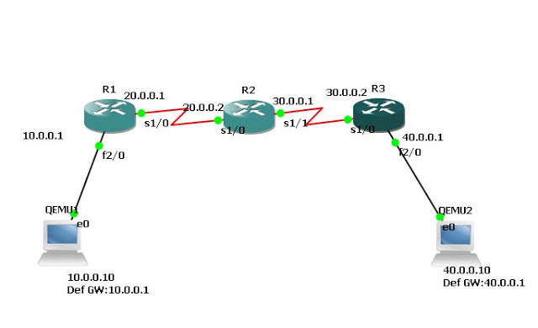](http://2.bp.blogspot.com/-NCkyHW-tn5s/UQ9X0-0mSWI/AAAAAAAAAF0/wb1Hx4w65Sc/s1600/1.jpg)

**Step 2**:Configure ip address for all interfaces and assign ip address,default gateway to hosts  
  
**In Router R1,**  
  
**R1(config)#interface fastethernet 2/0**  
**R1(config-if)#ip address 10.0.0.1 255.0.0.0**  
**R1(config-if)#no shutdown**  
**R1(config-if)#exit**  
 **R1(config)#interface serial 1/0**  
**R1(config-if)#ip address 20.0.0.1 255.0.0.0**  
**R1(config-if)#encapsulation ppp**  
**R1(config-if)#clock rate 64000**  
**R1(config-if)#no shutdown**  
**R1(config-if)#exit**  
 **In Router R2,**  
 **R2(config)#interface serial 1/0**  
**R2(config-if)#ip address 20.0.0.2 255.0.0.0**  
**R2(config-if)#encapsulation ppp**  
**R2(config-if)#no shutdown**  
**R2(config-if)#exit**  
 **R2(config)#interface serial 1/1**  
**R2(config-if)#ip address 30.0.0.1 255.0.0.0**  
**R2(config-if)#encapsulation ppp**  
**R2(config-if)#clock rate 64000**  
**R2(config-if)#no shutdown**  
**R2(config-if)#exit**  
 **In Router R3,**  
 **R3(config)#**  
**R3(config)#interface serial 1/0**  
**R3(config-if)#ip address 30.0.0.2 255.0.0.0**  
**R3(config-if)#encapsulation ppp**  
**R3(config-if)#no shutdown**  
**R3(config-if)#exit**  
 **R3(config)#**  
**R3(config)#interface fastethernet 2/0**  
**R3(config-if)#ip address 40.0.0.1 255.0.0.0**  
**R3(config-if)#no shutdown**  
**R3(config-if)#exit**  
  
**Step 3**:Configure RIP to all routers by using command,  
**In Router R1,**  
 **R1(config)#router rip**  
**R1(config-router)#network 10.0.0.0**  
**R1(config-router)#network 20.0.0.0**  
**R1(config-router)#exit**  
  
**In Router R2,**  
 **R2(config)#router rip**  
**R2(config-router)#network 20.0.0.0**  
**R2(config-router)#network 30.0.0.0**  
**R2(config-router)#exit**  
 **In Router R3,**  
 **R3(config)#router rip**  
**R3(config-router)#network 30.0.0.0**  
**R3(config-router)#network 40.0.0.0**  
**R3(config-router)#exit**  
 **Step 4**: Now check routing table of  route R1.Router will have all network information in its routing table, router learned this route by using rip.  
  
**R1#show ip route**  
**Codes: C - connected, S - static, R - RIP, M - mobile, B - BGP**  
**D - EIGRP, EX - EIGRP external, O - OSPF, IA - OSPF inter area**  
**N1 - OSPF NSSA external type 1, N2 - OSPF NSSA external type 2**  
**E1 - OSPF external type 1, E2 - OSPF external type 2**  
**i - IS-IS, L1 - IS-IS level-1, L2 - IS-IS level-2, ia - IS-IS inter area**  
**\* - candidate default, U - per-user static route, o - ODR**  
**P - periodic downloaded static route**  
 **Gateway of last resort is not set**  
 **C    10.0.0.0/8 is directly connected, FastEthernet2/0**  
**C    20.0.0.0/8 is directly connected, Serial1/0**  
**R    40.0.0.0/8 [120/2] via 20.0.0.2, 00:00:02, Serial1/0**  
**R    30.0.0.0/8 [120/1] via 20.0.0.2, 00:00:02, Serial1/0**  
  
  
**Step 5**:Now ping from host 10.0.0.10 to 40.0.0.10

[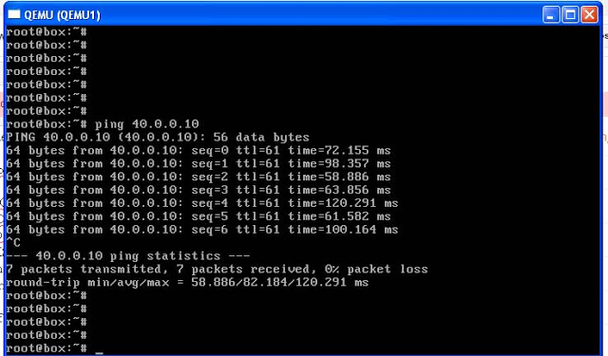](http://4.bp.blogspot.com/-sNR7Ur52nZo/UQ9dWbV0SUI/AAAAAAAAAGE/WvOT42Zvk14/s1600/2.jpg)

RIP Version 2  
  
RIP- Routing Information Protocol  
Administrative Distance-120  
Maximum Hop count-15,16 is unreachable network  
Metric - Hop count  
  
Rip version 2 supports CIDR(Classless Ineternet Domain Routing)  
  
To configure with rip version 2,just give this command,  
 **R1(config)#router rip**  
**R1(config-router)#version 2**  
**R1(config-router)#network 10.0.0.0**  
**R1(config-router)#network 20.0.0.0**  
**R1(config-router)#exit**

# [**How to configure OSPF Routing Protocol and Connect Areas**](http://chennaicisco.blogspot.in/2013/02/how-to-configure-ospf-routing-protocol.html)

**OSPF-Open Short Path First**,It is a Open Standard Routing Protocol  
  
Link State Routing Protocol  
Algorithm -Dijkistra,To find shortest path  
Administrativ Distance-110  
Metric- 10^8/Bandwidth  
Incremental Update  
Load Balancing Maximum 6 (Default 4)  
It knows Network topology  
Router ID-Initializes OSPF Process  
Fast convergence  
  
Timers  
Hello-10  
Dead-40  
Wait-40  
Retransmit-5  
  
**Step 1**:Create topology like below i have given

[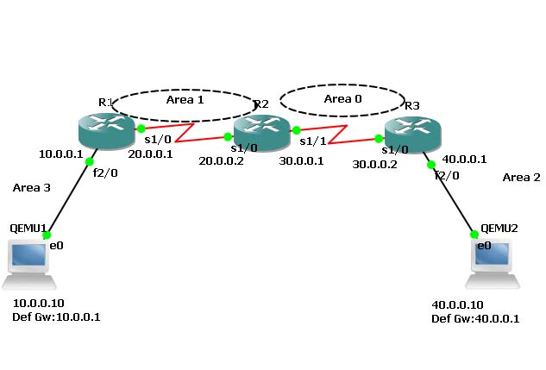](http://1.bp.blogspot.com/-5eRJ-YVs_Z4/URcfDZmLSeI/AAAAAAAAAGk/v1HEyPuVP0A/s1600/1.jpg)

**Step 2**:Cofigure ip addres to all interfaces  
  
 **In Router R1,**  
 **R1(config)#interface fastethernet 2/0**  
**R1(config-if)#ip address 10.0.0.1 255.0.0.0**  
**R1(config-if)#no shutdown**  
**R1(config-if)#exit**  
 **R1(config)#interface serial 1/0**  
**R1(config-if)#ip address 20.0.0.1 255.0.0.0**  
**R1(config-if)#encapsulation ppp**  
**R1(config-if)#clock rate 64000**  
**R1(config-if)#no shutdown**  
**R1(config-if)#exit**  
 **In Router R2,**  
 **R2(config)#interface serial 1/0**  
**R2(config-if)#ip address 20.0.0.2 255.0.0.0**  
**R2(config-if)#encapsulation ppp**  
**R2(config-if)#no shutdown**  
**R2(config-if)#exit**  
 **R2(config)#interface serial 1/1**  
**R2(config-if)#ip address 30.0.0.1 255.0.0.0**  
**R2(config-if)#encapsulation ppp**  
**R2(config-if)#clock rate 64000**  
**R2(config-if)#no shutdown**  
**R2(config-if)#exit**  
 **In Router R3,**  
 **R3(config)#**  
**R3(config)#interface serial 1/0**  
**R3(config-if)#ip address 30.0.0.2 255.0.0.0**  
**R3(config-if)#encapsulation ppp**  
**R3(config-if)#no shutdown**  
**R3(config-if)#exit**  
 **R3(config)#**  
**R3(config)#interface fastethernet 2/0**  
**R3(config-if)#ip address 40.0.0.1 255.0.0.0**  
**R3(config-if)#no shutdown**  
**R3(config-if)#exit**  
  
**Step 3**:Now,Enable ip routing by configuring ospf routing protocol in all routers,  
  
**In Router R1,**  
**R1(config)#router ospf 1**  
**R1(config-router)#router-id 1.1.1.1**  
**R1(config-router)#network 10.0.0.0 0.255.255.255 area 3**  
**R1(config-router)#network 20.0.0.0 0.255.255.255 area 1**  
**R1(config-router)#exit**  
 **In Router R2,**  
**R2(config)#router ospf 1**  
**R2(config-router)#router-id 2.2.2.2**  
**R2(config-router)#network 20.0.0.0 0.255.255.255 area 1**  
**R2(config-router)#network 30.0.0.0 0.255.255.255 area 0**  
**R2(config-router)#exit**  
 **In Router R3,**  
**R3(config)#router ospf 1**  
**R3(config-router)#router-id 3.3.3.3**  
**R3(config-router)#network 30.0.0.0 0.255.255.255 area 0**  
**R3(config-router)#network 40.0.0.0 0.255.255.255 area 2**  
**R3(config-router)#exit**  
  
You have to configure router id when we configure ospf.It is used to identify the router  
  
**Step 4**:Now check routing table of R1,  
  
**Router#show ip route**  
**Codes: C - connected, S - static, R - RIP, M - mobile, B - BGP**  
**D - EIGRP, EX - EIGRP external, O - OSPF, IA - OSPF inter area**  
**N1 - OSPF NSSA external type 1, N2 - OSPF NSSA external type 2**  
**E1 - OSPF external type 1, E2 - OSPF external type 2**  
**i - IS-IS, L1 - IS-IS level-1, L2 - IS-IS level-2, ia - IS-IS inter area**  
**\* - candidate default, U - per-user static route, o - ODR**  
**P - periodic downloaded static route**  
 **Gateway of last resort is not set**  
 **C    10.0.0.0/8 is directly connected, FastEthernet2/0**  
**C     20.0.0.0/8 is directly connected, Serial1/0**  
**O IA 40.0.0.0/8 [110/129] via 20.0.0.2, 00:04:23, Serial1/0**  
**O IA 30.0.0.0/8 [110/128] via 20.0.0.2, 00:07:29, Serial1/0**  
  
Here,R2 knows Area 0.Network 20.0.0.0 connected to R2 from R1,So R1 learns networks through this network.  
  
R3(config)#router ospf 1, Here, 1 is Process ID, it can be 1-65535.It initializes ospf process.  
            
There must be one interface up to keep ospf process up.So its better to configure loopback address to routers.It is a virtual interface never goes down once we configured.  
  
**R1(config-if)#interface loopback 0**  
**R1(config-if)#ip add 172.16.1.252 255.255.0.0**  
**R1(config-if)#no shutdown**  
  
**R2(config-if)#interface loopback 0**  
**R2(config-if)#ip add 172.16.1.253 255.255.0.0**  
**R2(config-if)#no shutdown**  
  
**R3(config-if)#interface loopback 0**  
**R3(config-if)#ip add 172.16.1.254 255.255.0.0**  
**R3(config-if)#no shutdown**  
  
**Step 5**:Now ,Check Routing table of R3,  
  
**R3#show ip route**  
**Codes: C - connected, S - static, R - RIP, M - mobile, B - BGP**  
**D - EIGRP, EX - EIGRP external, O - OSPF, IA - OSPF inter area**  
**N1 - OSPF NSSA external type 1, N2 - OSPF NSSA external type 2**  
**E1 - OSPF external type 1, E2 - OSPF external type 2**  
**i - IS-IS, L1 - IS-IS level-1, L2 - IS-IS level-2, ia - IS-IS inter area**  
**\* - candidate default, U - per-user static route, o - ODR**  
**P - periodic downloaded static route**  
 **Gateway of last resort is not set**  
 **O IA 20.0.0.0/8 [110/128] via 30.0.0.1, 00:18:58, Serial1/0**  
**C    40.0.0.0/8 is directly connected, FastEthernet2/0**  
**C    30.0.0.0/8 is directly connected, Serial1/0**  
  
Here,R3 doesn't know about the area 3 so we have to create virtual link between R1 and R2  
  
**Step 6**:Create virtual link between R1,R2,by this we create a virtual link to connect area 3 to area 0.  
  
**In Router R1,**  
**R1(config)#router ospf 1**  
**R1(config-router)#area 1 virtual-link 2.2.2.2**  
**R1(config-router)#**  
**\*Feb 10 10:29:23.767: %OSPF-5-ADJCHG: Process 1, Nbr 2.2.2.2 on OSPF_VL0 from LOADING to FULL, Loadi**  
**ng Done**  
 **In Rotuer R2,**  
**\*Feb 10 10:28:59.543: %OSPF-4-ERRRCV: Received invalid packet: mismatch area ID, from backbone area must be virtual-link but not found from 20.0.0.1, Serial1/0a**  
**\*Feb 10 10:29:09.535: %OSPF-4-ERRRCV: Received invalid packet: mismatch area ID, from backbone area must be virtual-link but not found from 20.0.0.1, Serial1/0.1.1**  
 **R2(config-router)#**  
**R2(config-router)#area 1 virtual-link 1.1.1.1**  
**R2(config-router)#exit**  
**R2(config)#**  
 **\*Feb 10 10:29:19.667: %OSPF-5-ADJCHG: Process 1, Nbr 1.1.1.1 on OSPF_VL0 from LOADING to FULL, Loadi**  
**ng Done**  
  
**Step 7**:R2 and R3 get updates about Area 3 .Now,Check routing table of R3,  
  
**R3#show ip route**  
**Codes: C - connected, S - static, R - RIP, M - mobile, B - BGP**  
**D - EIGRP, EX - EIGRP external, O - OSPF, IA - OSPF inter area**  
**N1 - OSPF NSSA external type 1, N2 - OSPF NSSA external type 2**  
**E1 - OSPF external type 1, E2 - OSPF external type 2**  
**i - IS-IS, L1 - IS-IS level-1, L2 - IS-IS level-2, ia - IS-IS inter area**  
**\* - candidate default, U - per-user static route, o - ODR**  
**P - periodic downloaded static route**  
 **Gateway of last resort is not set**  
 **O IA 20.0.0.0/8 [110/128] via 30.0.0.1, 00:01:56, Serial1/0**  
**C    40.0.0.0/8 is directly connected, FastEthernet2/0**  
**O IA 10.0.0.0/8 [110/129] via 30.0.0.1, 00:01:56, Serial1/0**  
**C     30.0.0.0/8 is directly connected, Serial1/0**  
  
**Step 8**:Check connectivity between host 10.0.0.10 to 40.0.0.10

[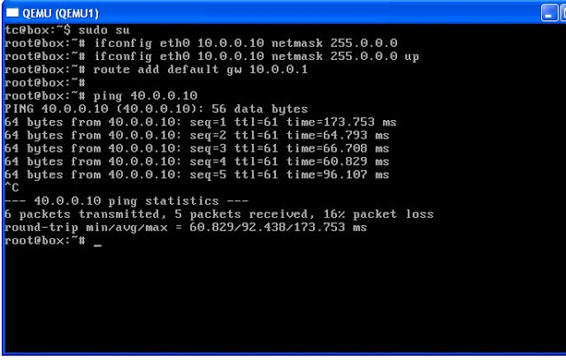](http://1.bp.blogspot.com/-380Fi5zXE6I/URcr0l82R_I/AAAAAAAAAG0/HUkaaZ-RyMU/s1600/2.jpg)

# **Trouble shooting** R3#show ip protocolsR3#show ip route ospfR3#show ip ospf neighbors detailR3#show ip ospf databaseR3#show ip ospf interface